1. Model

Variable: patid vstwk HBA1 G000 G120 female race6 bmi base_bmi;

Model: Hba1(or G000?) ~ vstwk;

Vstwk.speed ~ female+race6+trt+base_bmi+?

1. Number of visits

| **Num_ID** | **Frequency** | **Percent** | **Cumulative Frequency** | **Cumulative Percent** |
| --- | --- | --- | --- | --- |
| **1** | 43 | 1.33 | 43 | 1.33 |
| **2** | 54 | 1.67 | 97 | 3.00 |
| **3** | 68 | 2.10 | 165 | 5.10 |
| **4** | 113 | 3.49 | 278 | 8.60 |
| **5** | 190 | 5.88 | 468 | 14.47 |
| **6** | 64 | 1.98 | 532 | 16.45 |
| **7** | 68 | 2.10 | 600 | 18.55 |
| **8** | 60 | 1.86 | 660 | 20.41 |
| **9** | 56 | 1.73 | 716 | 22.14 |
| **10** | 60 | 1.86 | 776 | 24.00 |
| **11** | 65 | 2.01 | 841 | 26.00 |
| **12** | 52 | 1.61 | 893 | 27.61 |
| **13** | 86 | 2.66 | 979 | 30.27 |
| **14** | 97 | 3.00 | 1076 | 33.27 |
| **15** | 195 | 6.03 | 1271 | 39.30 |
| **16** | **949** | **29.34** | **2220** | **68.65** |
| **17** | **908** | **28.08** | **3128** | **96.72** |
| **18** | **106** | **3.28** | **3234** | **100.00** |

1. Plots for random participants

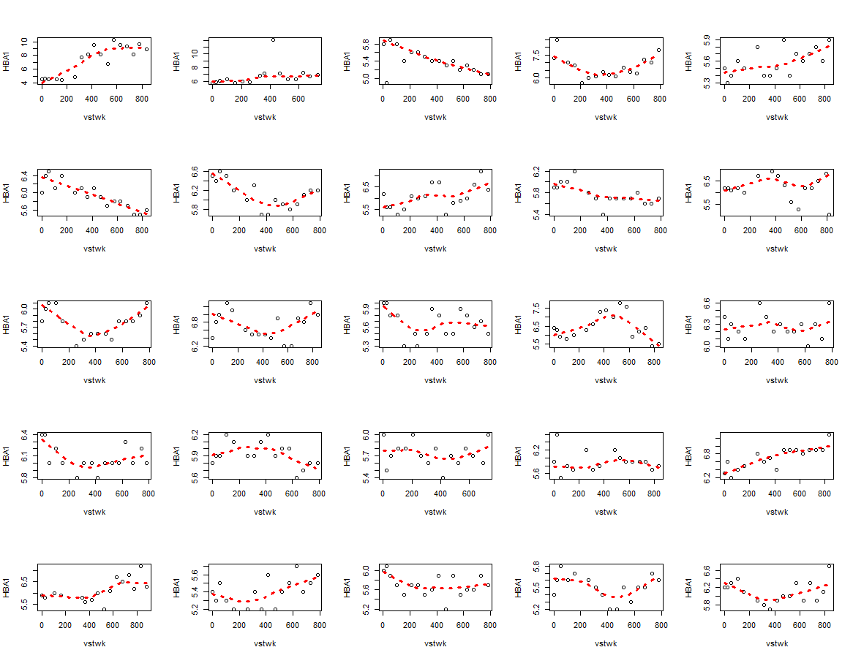

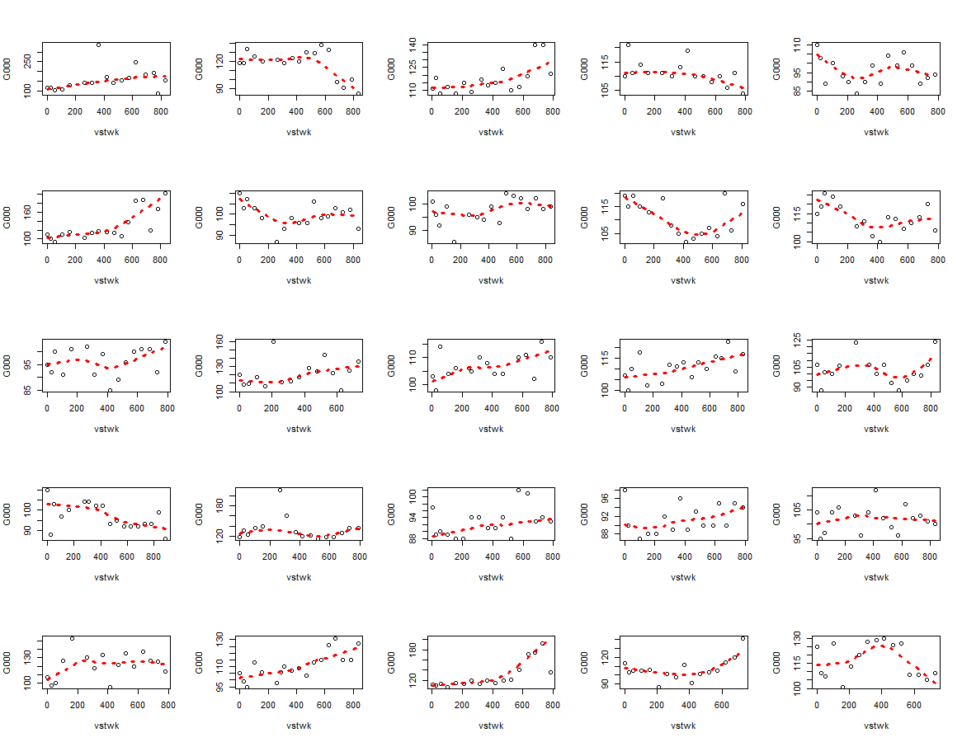

1. How to select starting value for covariates in NLME